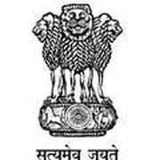
Government of West Bengal
Office of the Block development Officer
Karimpur-II Dev. Block
Mahishbathan, Nadia

Memo No:-1925(20)/KMP-II/MIS Cell/2011 Dated:-14/9/2011

To
The Prodhan & Executive Assistance Dhoradaha-I, Dhoradaha-II, Natidanga-I, Natidanga-II, Narayanpur-I, Narayanpur-II, Rahamatpur, Murutia & Dighalkandi.

Sub: - Rectify the Gram name of individual household in connection with new socio-economic survey.

Sending herewith a softcopy of Rural Household Survey generated from RHS software provided by P & RD Kolkata, with a request to rectify the Gram name (as per census Gram Name) of individual Households who have been wrongly included in the other Gram and submit the same to the Block MIS Cell within 20/9/2011 positively to help the undersigned take necessary action.

It is required for new socio-economic survey.

Enclo: - Soft copy of RHS.

Block Development Officer
Karimpur-II Dev. Block

